|  |  |
| --- | --- |
| Networking Infrastructure Diploma in CSF / IT  Year 2 Apr 2021 (Semester 3) | Week 2 |
| Practical |
| Ethernet Switching Technology | |

**OBJECTIVES**

1. To research on the specifications of an Ethernet switch
2. To understand resilience in switched Ethernet networks and the role of the Spanning Tree Protocol (STP)
3. To demonstrate the action of STP in loop avoidance and fault tolerance

**Activity 1**

**Objective:** To research on the specifications of an Ethernet switch

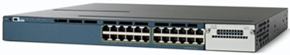

The above is a photo of the Cisco **WS-C3560X-24T-S** Ethernet switch. Search the Internet for the features of this switch and answer the following questions. (You should note the websites from which you obtain information.)

1. What is the total number of RJ-45 ports and what physical layer (PHY) standards do the ports support?

|  |
| --- |
| **24 Ports. 10Base-T/100Base-TX/1000Base-T** |

1. Explain the advantage of Store-and-Forward switching mode used by this switch.

|  |
| --- |
| **Prevents wasting bandwidth on the destination network due to bad frames which can degrade network performace.** |

1. Does this switch support Spanning Tree Protocol (STP)?

|  |
| --- |
| Yes this switch supports (R)STP |

1. What is full duplex connectivity supported by switch?

|  |
| --- |
| Full duplex connectivity means that the devices can both send and receive simultaneously without having to take turns to send and receive data over one channel. |

1. Explain what is Rack Unit (RU or U).

|  |
| --- |
| **Rack unit is a unit of measurement defined as 1.75 inches. Most frequently used as the unit of measurement for 19 and 23 inch rack frames.** |

1. Why is it important to state the external dimensions of the switch?

|  |
| --- |
| So that we know how many devices a switch can handle and how much space it will take up on a rack as well as the compatibility with the devices that are to be connected. |

1. Does this switch support PoE, if so, in what capacity? State 3 examples where PoE could be used.

|  |
| --- |
| **No it does not support PoE as it does not have a P in its name and it does not have a yellow line beneath its ports.**  **PoE can be used for VoIP, Surveillance cameras and Wireless devices** |

1. What do you understand that this **WS-C3560X-24T-S** switch is a layer-3 (or multi-layer) switch?

|  |
| --- |
| **It can operate at higher layers of the OSI model. It can perform the functions of a router at a high level. Performs switching at the network layer.** |

**Activity 2**

**Objective:** To understand resilience in switched Ethernet networks and the role of the Spanning Tree Protocol (STP)

**Switch2**

**Switch1**

PC2

PC4

PC3

PC1

The above is a diagram of a switched Ethernet LAN. All the nodes are connected to the Ethernet ports of the switches, and the two switches are connected by two separate links.

1. Is the network shown above resilient? Explain your answer.

|  |
| --- |
| **Yes. If one of the links between switch 1 and switch 2 fails, there is still another linkage between them that can transmit data between the PCs.** |

1. What problem could arise if the two switches do not support the Spanning Tree Protocol (STP)?

|  |
| --- |
| Without STP, as this network has a loop, broadcast storms, multiple frame transmissions and inconsistent switch table all will occur. |

1. How does STP prevent the problem mentioned in Step 2 without compromising the reliability of the network?

|  |
| --- |
| **STP shuts down redundant paths. There will be redundant paths if there are loops as there needs to be just one path to each device at a time. However, should hardware fail, these redundant paths must be ready to be opened. STP does all these quickly and automatically.** |

**Activity 3**

**Objective:** Todemonstrate the action of STP (Spanning Tree Protocol) in loop avoidance and fault tolerance.

**Switch2**

**Switch1**

PC2

PC1

1. Set up the network shown above using two CISCO switches and two PCs. UTP cables are used for the connections. Power on the switches and PCs.
2. Write down the Cisco switches’ port numbers that are used in the above network diagram. You may use any ports.
3. Login to PC1 and PC2. Manually configure the static IP addresses and subnet masks of PC1 and PC2 as follows:

PC1: IP address **192.168.1.1** and subnet mask **255.255.255.0**

PC2: IP address **192.168.1.2** and subnet mask **255.255.255.0**

Note: In the lab, for convenience, you may use the APIPA addresses: 169.254.x.x instead. These addresses are automatically configured when PC1 and PC2 could not find any DHCP server.

1. Use the computers to ping one another and observe the results. (On PC2 command prompt, type **ping 192.168.1.1** and vice versa.

Note you may need to **turn off the Windows firewall on both PCs** to get positive ping replies).

1. Now we will try to determine the status of the ports on the Cisco switches (whether they are ***forwarding or blocked***).
   1. First connect the **COM port** of **PC1** to **Cisco Switch1’s console port** using the **special RJ-45-to-DB9 console rollover cable (blue ribbon)**.
   2. Start the program **Putty** on your desktop.

The program should look similar to the figure below:

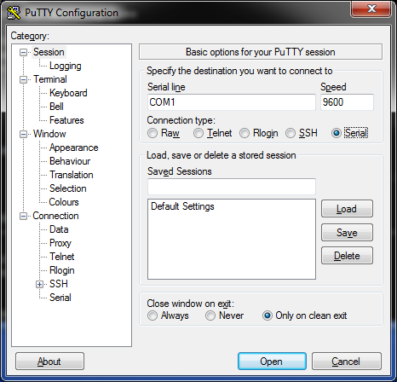

Select **Serial** for Connection type, change COM1 to COM3 and click **Open**.

Note: use Device Manager to confirm that it is COM3.

Hit Enter and a “Switch >” prompt will appear on the Putty screen. If during the start-up process you see a message “**Would you like to enter the initial configuration dialog? [yes/no]** :” Answer **no**.

After a display of some systems messages, hit Enter and a “Switch >” prompt will appear.

Enter the command ***show spanning-tree*** at the prompt as shown below***:***

Switch1> **enable**

Switch1# **show spanning-tree**

*A typical sample output is shown below:*

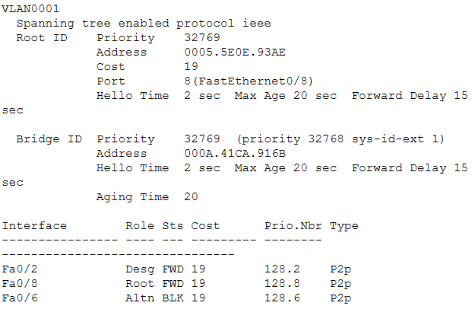

To find out the port status, look under **Sts**. **FWD indicates forwarding while BLK means blocking.**

Write down the port status (forwarding or blocking) of Switch1.

1. To find out the port status of Switch2, do the same thing except connect the special RJ45-to-D9 cable to Cisco **Switch2’s** Console port.
2. Enter the command ***show spanning-tree*** at the prompt as shown below: Switch2> **enable**

Switch2# **show spanning-tree**

Write down the port status (forwarding or blocking) of switch2.

Which switch port is in blocking state?

Port 5

Note: The spanning tree algorithm is used to compute and determine the status of different switch ports.

1. On PC1’s command prompt type the following command prompt:

**Ping -t 192.168.1.2** (-t option to ping **continuously** till CTRL-C)

1. There are 2 links from PC1 to PC2. Simulate a failure in the link **where both the switch’s ports are in forwarding mode** by unplugging one of the connected ports.

Observe the ping replies on PC1 and show the screen capture below:

|  |
| --- |
| Prior to one of the connected ports being pulled out, the pings sent were successful but once it was pulled out, it showed “Request Timed out”. However after a while, the pings started to be successful again. |

1. Explain what you observe and why STP has resulted in the above output:

|  |
| --- |
| This is because the port that was pulled out was the port that was forwarding data. Once I was pulled out, the other port which was previously blocked was activated by STP which took a while hence cause Request timed out for a short period of time before the pings become successful again showing that the port has been reassigned and is now forwarding data. |

1. Explain what happens if the failed link is reconnected back?

|  |
| --- |
| If the failed link is connected to a higher port number nothing will happen as it has lower priority, however if it is connected back to its original position (higher priority) then STP will reassign the ports and make it the port that forwards data which the other port will go back to being blocked. |

**Conclusions**

1. Redundant paths in extended switched LANs increase reliability of the LAN, but they may give rise to network loops which result in multiple copies of a frame reaching the destination and broadcast storm.
2. The main task of the Spanning Tree Protocol (STP) is to prevent the occurrence of network loops in extended switched LANs.